
GUIDELINES AND TECHNICAL REQUIREMENTS
DISPLAY OF VERTICAL BANNERS ON PUBLIC STREET LAMP POSTS
- The displaying of vertical banners on the lamp posts within Public Street is only allowed for national events, major festivals (E.g. National Day, Christmas Day, Hari Raya Puasa, Deepavali, Chinese New Year etc.) and events supported or organised by a relevant government agency.

- For request of lamp post banner spaces in a single precinct as listed below, please submit the application to the relevant agency directly.
Precinct | Agency | Remarks
Arts and Heritage Precinct (i.e. Bras Basah area) and Civic District | National Arts Council (NAC) | List of roads & application guidelines can be found at:  https://www.nac.gov.sg/whatwedo/support/arts-spaces/npp.html
Orchard Precinct, key tourism belts, Tuas & Woodlands causeways | Singapore Tourism Board (STB) | List of roads & application guidelines can be found at:  http://www.visitsingapore.com/mice/en/plan-your-event/planning-toolkit/street-banners-location/

- For request of lamp post banner spaces in multiple precincts, please submit the application to LTA at LTA_Licensing_TDS_VBanner@lta.gov.sg

Submission Requirements for Lamp Post Banner Spaces Applications to LTA

Submission Timeline (including multiple precinct applications)
- Banner space booking will only be open 3 months prior to the banner display start date
- Banner display start date should not be more than 1 month before event commencement date.

Documents Required for Submission
- Supporting letter from any relevant Government Agency for the event. (Supporting letter with the government organisation letterhead should be addressed to LTA.)
- Banner Request Form. Click here to download form and fill up the required details.
- Soft copy of the banner artwork (PDF, JPG less than 5mb) at least 5 weeks before banner display period. Any delay in submission will affect the overall approval process.
(Please submit application to LTA at LTA_Licensing_TDS_VBanner@lta.gov.sg)

Submission Guideline
- Maximum number of roads allowed for each application: 6 roads
[Banners may be displayed on lamp posts along all roads with approval from the relevant agencies, except on Expressways (including slip road exiting from and leading to expressway) and flyovers]
- Maximum display duration: 1 month

Submission Processing
- Upon receipt of valid and completed submission, applicant will be informed of banner space availability within 2 months.
- Under the Building Control (Outdoor Advertising) Regulations, all signs to be displayed outdoor on any premises must have a license granted by the Building and Construction Authority (BCA) if required by BCA. LTA will assist the applicant to enquire with BCA if a license is required. We will inform the applicant if a license is required and the applicant may apply for it through BCA’s Advertisement Licensing System at this website: https://eservices.bca.gov.sg/advertisementlicence

Submission Withdrawal
- For any withdrawal (all or partial) of the allocated banner spaces, please inform via LTA_Licensing_TDS_VBanner@lta.gov.sg at least 1 month before banner display date

Banner Design Specifications

- The specifications for the banner design is as shown below:-

All names and logos of the sponsors and organisers in this space only.

Mandatory to include the name or logo of the government agency supporting your event at the bottom of all banners.

Key Message (i.e. Event Name, Date and Venue).

Event logo is allowed on the main body of the banner design.

The key message shall cover at least 50% of the banner design space.

The name or logo of sponsors and organisers can only cover 15% of the total design space

 | Types of Lamp Posts
 | Non-decorative |  | Decorative | Civic District
Photos | 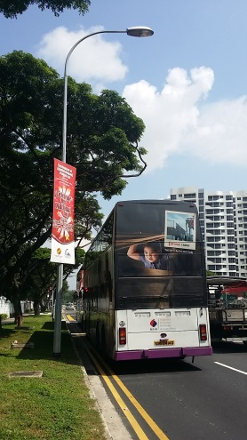 |  | 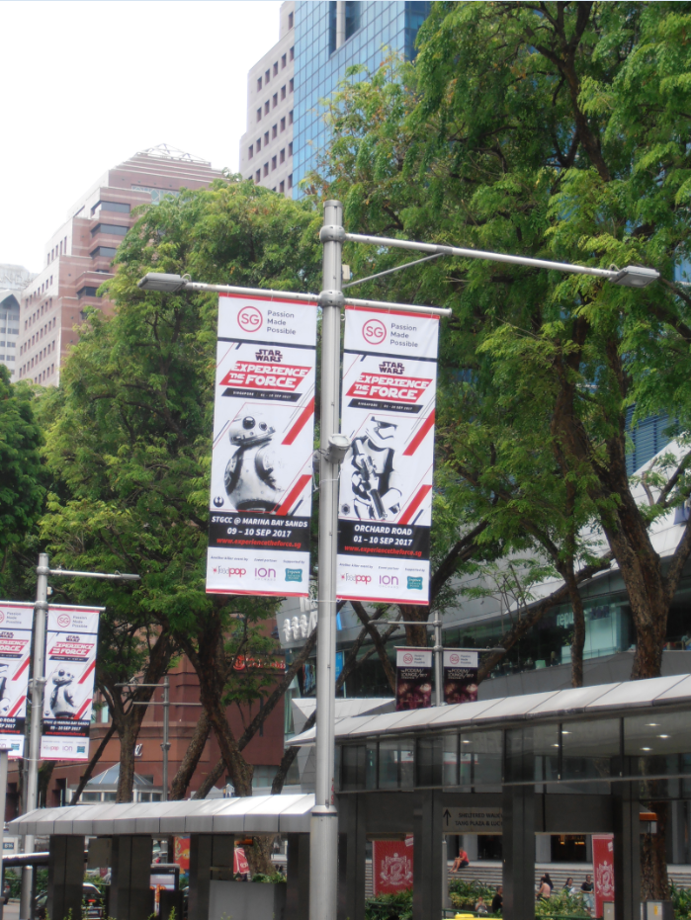 | 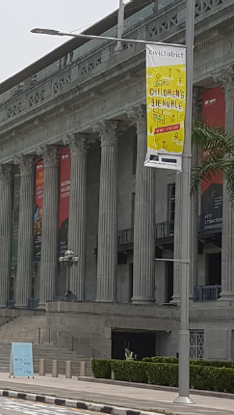
Banner  Dimensions | 3 metres by 1 metre |  | 3.5 metres by 1.2 metres (i.e. along Orchard Road, Tanglin Road and Scotts Road) | 3 metres by 0.75 metres
Banner  Dimensions | (Note: Banner size must correspond to lamp post type and must not exceed the specifications provided)
Banner Sides | Single Sided Only | Double-sided only
Banner Design  Guidelines | Allowable  - Messages, such as website address or hotlines specific to the event  Prohibitions  - No over cluttering of texts  - No call-to-action messages  - No italic and serif (cursive) fonts  - No message in vertical orientation  - No commercial messages e.g. information on ticket prices  - No graphics that are immoral, indecent, obscene or inappropriate in nature or racially or religiously offensive to the public  - No design and colour which is similar to any road-related and traffic signs and traffic lights  Note: Banner content should also conform to the guidelines as set by the Advertising Standards Authority of Singapore in the Singapore Code of Advertising Practice.
Banner Printing | Electrostatic, direct-to-media, high grade silkscreen or more superior printing techniques should be used to ensure clear images and prevent fading.

Installation/ Maintenance of Vertical Banners

- Upon allocation of banner space availability, the applicant shall be responsible to conduct a site recce on the location that they are allocated to place the banners. Site survey shall also include the recording of the identity numbers of the street lamp post and to observe the type of lamp post.

- All banners shall maintain a minimum height clearance of at least 2.4 metres above the walkway/ grass verge and minimum lateral clearance of 600 mm away from the road kerb edge. Banners on lamp post immediately before traffic lights shall have a minimum height clearance 3m above ground. The lamp post number and the service door must not be blocked at all times.

- All banners must be located 50m away from signalised junction.

- No installation of banner is allowed on the lamp post immediately before the Arterial Variable Message Signs (AVMS) and Parking Guidance Signs (PGS).

- No installation of banners is allowed on lamp posts with traffic/ information signs, cameras and monitoring devices. Please refer to the list of these locations (Click here to download).

- All the banners and their structures shall not obstruct pedestrian footpaths, walkways, street lights, traffic lights, AVMS, PGS, directional signs, overhead gantry signs and bus stops.

- Prior to the installation of the banners, the applicant shall check with LTA if they are unclear which lamp posts are not suitable for the display.

- The applicant is responsible to take photographs to record the conditions of the lamp post, footpath, road and street furniture before commencement of the work and submit it to LTA should there be any defects found. After the event, the applicant is responsible to make good any defects, which were not recorded in the photographs.

- For decorative lamp posts, the applicant shall arrange joint site meeting with LTA’s Term Contractor before and after the display with 7-days’ notice.

- No drilling, riveting or welding shall be allowed for mounting of supports on the lamp post/ traffic light post/ traffic sign post.

- Banners must incorporate an eyelet with steel/ wire cable to be securely tied to the lamp post to prevent flagging and not to cause any dislodgement. A sturdy wooden/ plastic/ metal strip can be incorporated at the bottom of the banners to hold the banner to make sure it is straight. They shall not interfere with any of the electrical parts of the lamp post and become hazardous to the workmen or the public.

- U-Clamp with PVC sleeves must be used to mount the banner on all galvanised lamp posts without metal rods. Appointed Contractors from LTA will remove any banners on lamp post found not using U-clamp with PVC sleeves. The cost incurred shall be borne by the applicant. The applicant will be responsible to make good any defects, scratches or damages on the lamp posts at their own cost after the event.

- Please see the below photo on a suitable mounting method for compliance.

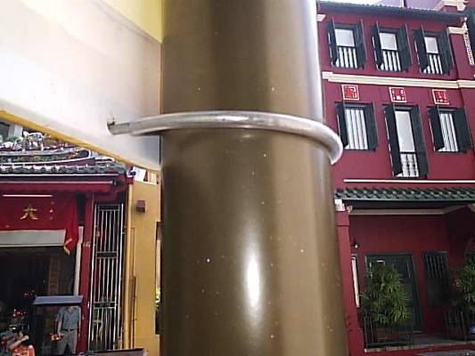
Clear sleeve on the U-clamp to protect the pole

- Where decorative lamp post with metal rods for fixing of banners are provided (i.e. in the Civic District, Orchard Road, Tanglin Road and Scotts Road), these shall be used for displaying vertical banners only.

- All banners must be installed and dismantled between 2300hrs to 0600hrs on the following day.

- The applicant or your appointed contractor shall provide temporary traffic warning signs and control devices in accordance with the LTA Code of Practice for Traffic Control at Work Zone during the installation/ dismantling/ maintenance. For more information, you may download the latest version of the Code of Practice for Traffic Control at Work Zone in LTA website under sub-sections, “Industry Matters”, “Development Building, Construction & Utility Works”, “Street Proposals and Works on Public Streets”.
.
- The applicant shall ensure the following:-
- the banners remain in good condition/ cleanliness during the period of display; and
- conducting daily inspections to ensure that the structures/ banners are adequately secured, clean and safe. Any banners, which in the view of the authorities pose safety concern must be removed/ replaced immediately.

- All the banners and their supporting structures are to be dismantled and removed immediately within 48 hours after the banner display end date. Otherwise, the Authorities will remove the structures/ banners and the cost incurred shall be borne by the applicant.

- Public liability insurance and other insurance shall be readily available when requested by the Authorities.

- The applicant shall be responsible to address any public feedback and enquiries that may arise from the installation/ display of the banners.

- The Authorities reserve the right to revoke any approval and also the right to instruct the immediate removal of the banners at the applicant’s cost without any compensation as and when required.

- The applicant is to be responsible and address any feedback directly to the relevant agency if the surveillance cameras and wireless antenna panels were found to be blocked/ obstructed / adjusted during installation/ dismantling/ maintenance. The applicant shall bear the full cost in making the said equipment back to its original state to the satisfaction of the relevant agency.

- The applicant shall be responsible for any incident or damage and shall indemnify the Government Agencies and LTA against all proceedings, action, claims, demands, damages, injury to persons (whether fatal or otherwise), loss or damage to property, costs and expenses whatsoever and howsoever arising out or in connection with damage to the property/ surrounding properties or injury to person(s) from the banner display and during installation/ dismantling works.

- Unauthorised banners (e.g. additional banners which are not approved by LTA) shall be classified as illegal advertisements and enforcement action would be taken against the applicant under the “Street Works (Advertisement on Road Structures, Road Related Facilities and Public Streets) Regulations 2003”.

- Failure to comply with any of the above requirements may result in applicants and their appointed contractors being blacklisted and not allowed to apply for future applications.

